Porcelain Bouquet Prerequisits.

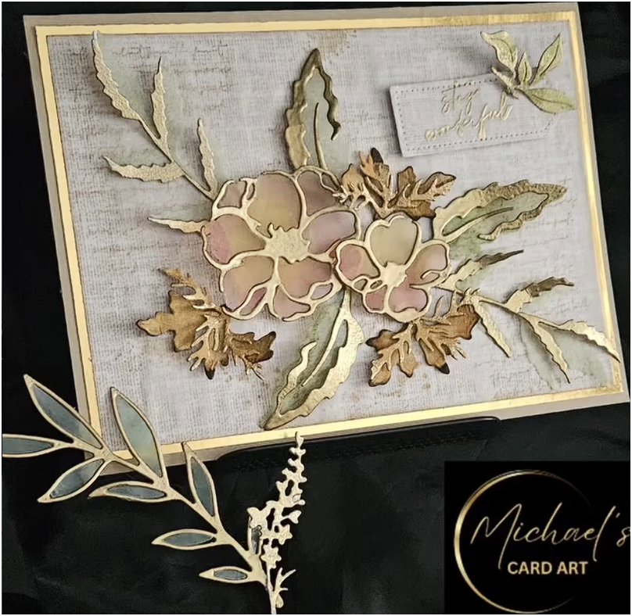

Preparation for Participants
The Porcelain Blossoms workshop relies on a very specific style of die, so please take a moment to review your stash before enrolling.
The ideal die has an outer cutting edge and an inner opening, creating a frame-like shape. This design allows us to emboss and shape the outer petals while colouring vellum separately and inlaying it into the centre of the die-cut element — a key technique used throughout this workshop.
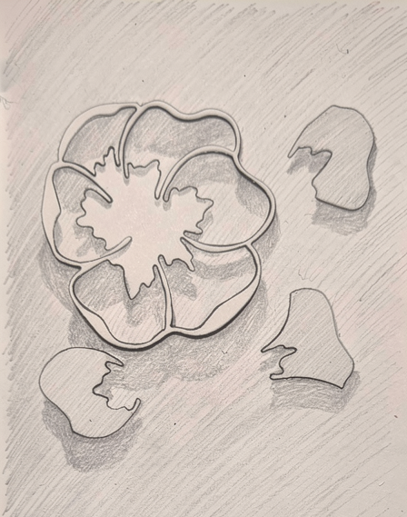
Profile of the ideal file for this workshop
Whilst I will be using Stampin Up products, you are welcome to use dies from any manufacturer, provided they have the same construction and are suitable for vellum inlay.
If you are unsure whether your dies will work, please send me a photograph or description of the die set before the workshop. I am very happy to help you determine its suitability.
Please note: "This particular die style is central to the Porcelain Blossoms technique, so ensuring you have a suitable die beforehand will help you get the most from the workshop."
For this workshop I’ll be using two sets from Stampin Up.
Petals of Beauty Peaceful Monents
